
Update date, xx xxxx

Visa Debit Card Dispute Management
PROCESS

October 1, 2026

Document Tracking and Control Table

Policy Owner | TBC
Approval Date | TBC
Version | TBC
Access Level | TBC
Policy Author | TBC
Subject Matter Expert(s) | TBC
Last Full Review Date | TBC
Update Date (changes were made but a full review was not necessarily conducted) | TBC
Review Frequency Requirement | TBC
Changes made | TBC
Stakeholders Impacted | TBC

Purpose
The Visa Debit Card Dispute Management Procedure guides the Growth, Payment Services, Fraud Prevention, and Finance teams in managing member-initiated Visa Debit Card disputes. It sets out a consistent approach for receiving and triaging dispute claims, gathering and assessing supporting documentation, issuing provisional credit, submitting and managing disputes through Central 1 and the Visa network, and resolving disputes and recovering funds where applicable. It also covers the roles and systems involved, the process flows, and the detailed procedures across the dispute management lifecycle.

Scope
This procedure applies to all team members involved in the intake, triage, investigation, submission, and resolution of member-initiated Visa Debit Card disputes, received through the following channels:
- Branch: occurs when a member visits Beem’s branch to dispute a Visa Debit Card transaction.
- Contact Centre: occurs when a member contacts Beem’s Growth Team by phone to dispute a Visa Debit Card transaction.
This procedure covers the five stages of the dispute management lifecycle:
Stage 1. Dispute Intake
Stage 2. Dispute Triage
Stage 3a. Case Preparation & Document Assessment
Stage 3b. Provisional Credit Issuance
Stage 4. Network Submission & Response
Stage 5. Resolution & Recovery

Roles and Systems
The following roles and systems support various activities within the Visa Debit Card Dispute Management Procedure.
Role / System | Responsibility
Growth Team | Front-line contact centre and branch staff who maintain contact with members, receive the member's dispute claim, verify the cardholder and impacted transaction(s), records dispute details. Where required, they perform initial account security actions, such as blocking and reissuing the card.
Payment Services Team | Investigates and manages non-fraud (recognized/authorized transactions) disputes referred by the Growth Team, prepares case documentation, submits eligible disputes to Central 1, and manages dispute outcomes and recoveries for non-fraud cases.
Fraud Prevention Department | Fraud Management / Fraud Specialists provide centralized expertise and coordination to support consistent fraud detection, escalation, investigation, response, recovery, and reporting practices across the organization. They are responsible for leading or coordinating fraud investigations and case management activities, supporting appropriate evidence and documentation practices, and enabling effective cross-functional coordination and governance visibility for significant fraud risks, trends, and incidents.  Key responsibilities may include:  - conducting or coordinating fraud investigations and case management activities,  - maintaining case documentation and supporting appropriate evidence handling practices,  - coordinating escalation, response, containment, and recovery activities with relevant operational and support functions,  - supporting reimbursement and remediation activities in accordance with established guidelines and approvals,  - monitoring fraud trends, emerging risks, and typologies to inform detection and control improvement opportunities,  - supporting fraud reporting, analytics, and governance visibility into material incidents and trends,  - providing operational guidance and input into training and awareness materials,  - coordinating with external parties (e.g., law enforcement, insurers, payment networks) where appropriate.
Finance Team | Validates and posts provisional credit to the member's account within pre-defined SLAs, tracks provisional credit aging and reversal, finalizes or reverses provisional credit based on the dispute outcome, and records recoveries, losses, fees, and general ledger entries.
Central 1 | Beem's financial services partner that receives completed dispute submissions and routes them, via PPJV, to the FIS Everlink Settlement team for submission to Visa Resolve Online (VROL) on Beem's behalf.
FIS Everlink (Everlink) | Beem's Visa Debit program processor. Submits dispute requests to Visa on Beem's behalf via VROL, and manages the pre-arbitration and arbitration cycle in accordance with Visa Rules and pre-defined processes and timelines.
CRM (Dynamics 365) | System of record used to create and track dispute cases and trigger both the ATM/POS trace (non-fraud) and Fraud Intake Form (FIF) (fraud) workflows.
DNA | Beem's core banking system used to review member and account information and apply card or account restrictions.

Stage 3A: Case Preparation & Document Assessment (Payment Services / Fraud)

6.1 Process Flow
The visual overview below provides the end-to-end process for case preparation and document assessment. This stage is owned by the Payment Services / Fraud teams. [Feedback – we need to make sure its either ‘Payment Services Team’ or ‘Payment Services Team member’ or ‘Fraud Prevention Department’ or ‘Fraud Specialist.]
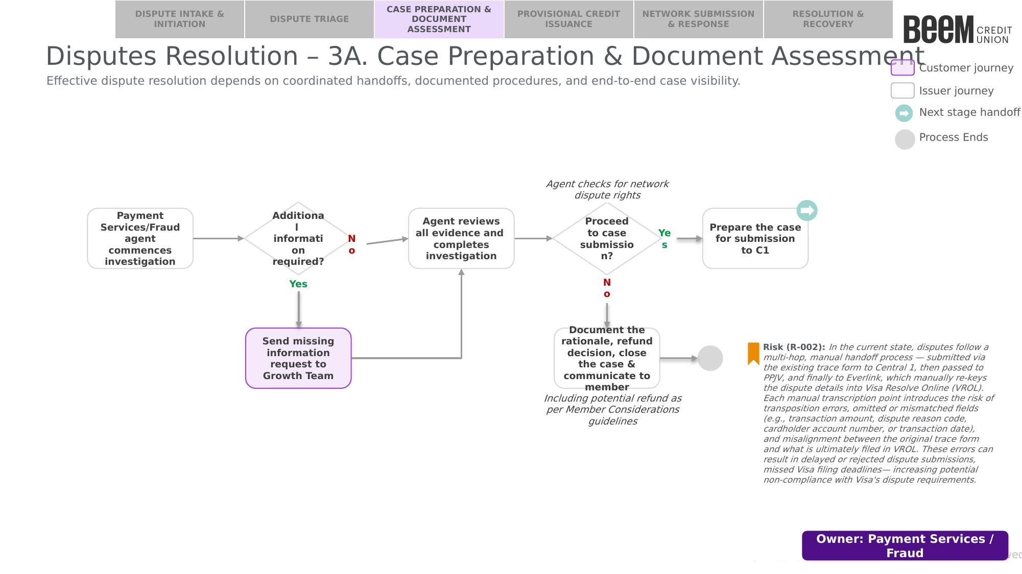

6.2 Procedure
The following procedure provides a step-by-step outline of the activities performed by the assigned Payment Services or Fraud agent as part of case preparation and document assessment.

6.2.1 Commence Investigation
Upon proceeding from Stage 2 — Dispute Triage, the assigned agent commences [Feedback – same as above, agent is not the right word] investigation of the case:
- Fraud: the Fraud Specialist should follow the Visa Debit Card Fraud Investigation Process. [Feedback: this should be bullet point and also we should call out the team its for not the fraud type, another point of feedback is when we refer to another rdocument we should say ‘please refer to the X procedure” we should also mention something about proceeding to 6.2.3 when done]
- Non-Fraud: the Payment Services agent should follow Section 6.2.2 — Non-Fraud Investigation below. [Feedback – same as above we should also call out team ‘Payment Services Team:” instead of “Non-Fraud:”]
Note: the Visa Debit Card Fraud Investigation Process is a separate, dedicated procedure and is out of scope for this document. Both paths resume at Section 6.2.3 — Assess Network Dispute Rights and Proceed to Case Submission once investigation is complete. [Feedback – I don’t think this note adds any value

6.2.2 Non-Fraud Investigation (Payment Services)
Step 1 — Review referral and available information: [Feedback – I think we should break this up into separate sections 1. Review referral and available information 2. Conduct investigation 3. Determine and record investigation outcome basically we should be determining if it’s a valid dispute or invalid dispute.. similar to The Fraud Investigation Process section 4.2.3. Basicaly if the dispute is valid then proceed to next section if not then document rationale and and close crm case ] upon receipt of the case, the Payment Services agent must review the case and available information to determine whether sufficient information is available to proceed with the investigation. The agent should verify that the following information is available for review, including but not limited to: [Feedback – make the below bullet points not numbered]
- Member and account information (suggested source: CRM case, DNA).
- Transaction details, including date, amount, merchant, and network type (suggested source: CRM Transaction Details, DNA).
- The member's dispute narrative and reason for dispute (suggested source: CRM Dispute Narrative).
- The completed ATM/POS Trace Request fields, including method of instruction and any prior merchant contact details (suggested source: CRM case).
Based on the above, determine whether there is sufficient information available to conduct the investigation:
- If the information is complete: proceed to Step 2 — Conduct investigation. [Feedback – if statements should be bullet points]
- If information is incomplete: send a missing information request to the Growth Team. Once sufficient information is received, proceed to Step 2 — Conduct investigation.
Step 2 — Conduct investigation: the Payment Services agent should use the investigation matrix below as a guide to review the available information and determine whether it supports the member's reported dispute. [Feedback – can we make this a simpler table basically some checks to determine if there are any red flags, like transaction details not matching, the disputed amount seems to have gotten reversed or refunded by Merchant already (by checking DNA), stuff similar to this (simple) and obviously checkin gif member has a history of dispute pattern, should be a simpler table].
# | Review Area | Specific Data Elements | Indicators Supporting Dispute | Indicators Inconsistent with Dispute
1 | Transaction Data  (suggested source: CRM, DNA) | Date, amount, merchant, transaction channel/network type | Transaction details on file match the member's claim and the ATM/POS Trace Request | Transaction details on file do not match the member's claim
2 | Dispute Reason & Supporting Evidence  (suggested source: CRM Dispute Narrative, member-provided documentation) | Evidence relevant to the stated reason for dispute (e.g., order confirmation, proof of non-delivery, expected vs. billed amount, duplicate transaction records) | Evidence substantiates the member's stated reason for dispute (e.g., confirms non-delivery, incorrect amount, or duplicate charge) | Evidence contradicts or does not support the member's stated reason for dispute
3 | Merchant Contact  (suggested source: CRM Dispute Narrative) | Whether the member contacted the merchant, and the merchant's response | Merchant was unresponsive, declined to resolve the issue, or did not provide an adequate remedy | Merchant resolved the issue directly with the member (e.g., issued a refund or replacement)
4 | Member History & Dispute Pattern  (suggested source: DNA) | Prior disputes on file within a rolling 12-month period | No significant dispute history identified | A pattern of frequent or repeated disputes, which may indicate Refund/Dispute Abuse (see the Visa Debit Card Fraud Investigation Process — First-Party Fraud) and should be escalated for further review
Capture the investigation notes and findings in the CRM case. [Feedback – yeah then proceed to the next section
Step 3 — Record investigation outcome: based on the totality of evidence identified during the investigation, document the investigation findings and whether the evidence supports the member's reported dispute in the CRM case notes. Proceed to Section 6.2.3 — Assess Network Dispute Rights and Proceed to Case Submission. [Feedback – this step should now be a new section Determine and record investigation outcome, basically based on the investigation outcome, if no valid dispute like red flags then document rationale and close case, if it seems to be valid dispute then proceed to next section ]

6.2.3 Assess Network Dispute Rights and Proceed to Case Submission
Once investigation is complete (Fraud: per the Visa Debit Card Fraud Investigation Process; Non-Fraud: per Section 6.2.2 above), the assigned agent should assess whether the dispute is eligible for submission, based on the investigation findings and the applicable network dispute rights criteria (see the Everlink — Visa Debit Program Chargeback User Guide):
- Non-Fraud: the dispute must have a valid dispute code (i.e., fall within one of the applicable Visa Dispute Category 12 or 13 conditions).
- Fraud: the disputed transaction must not be a Secure Electronic Commerce Transaction that was fully 3-D Secure authenticated (Card-Not-Present), and the dispute must fall within the limit of 35 disputes for a single cardholder PAN within the previous 120 calendar days — a submitted dispute beyond this threshold is invalid.
  - Note: where a case involves more than 35 disputed transactions on the same PAN, the Fraud Specialist should initiate disputes for the 35 transactions with the highest dollar amount.
Based on the above, determine whether to proceed to case submission:
- If proceeding to case submission: set the CRM case status to “Submitted to Central 1”. Prepare the case for submission to Central 1 (C1), and proceed to Stage 4: Network Submission & Response. [Feedback – if like I mentioned, if statements should be bullet points, only numbered if there are sequenetial steps involved].
- If not proceeding to case submission: document the rationale and refund decision (including any potential refund as per the Member Considerations guidelines) in the CRM case notes, close the case by setting the CRM case status to “Closed”, and communicate the outcome to the member. This procedure ends.

